Northbrook Public Library
**** Advanced Excel 2013 ****

Relative & Absolute Cell References
Excel uses two types of cell references to create formulas. Each has its own purpose. Read on to determine which type of cell reference to use for your formula.
Relative Cell References - This is the most widely used type of cell reference in formulas. Relative cell references are basic cell references that adjust and change when copied or when using AutoFill. Example:
=SUM(B5:B8), as shown below, changes to =SUM(C5:C8) when copied across to the next cell.
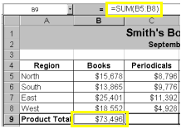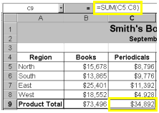

Absolute Cell References
Situations arise in which the cell reference must remain the same when copied or when using AutoFill – you need to “lock-into” a cell. Dollar signs are used to hold a column and/or row reference constant.

Example:
In the example on the next page, when calculating commissions for sales staff, you would not want cell B10 to change when copying the formula down. You want both the column and the row to remain the same to refer to that exact cell. By using $B$10 in the formula, neither changes when copied.

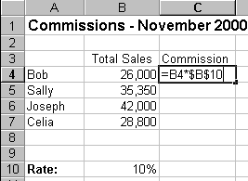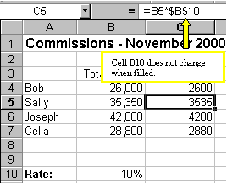
A more complicated example is below (Review this later): Let's pretend that you need to calculate the prices of items in stock with two different price discounts. Take a look at the worksheet below.
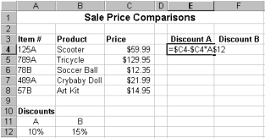
Examine the formula in cell E4. By making the first cell reference $C4, you keep the column from changing when copied across, but allow the row to change when copying down to accommodate the prices of the different items going down. By making the last cell reference A$12, you keep the row number from changing when copied down, but allow the column to change and reflect discount B when copied across. Confused? Check out the graphics below and the cell results.
Copied Across
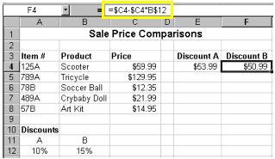
Copied Down
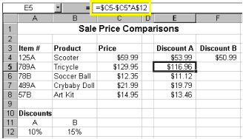

Now, you might be thinking, why not just use 10% and 15% in the actual formulas? Wouldn't that be easier? Yes, if you are sure the discount percentages will never change - which is highly unlikely. It's more likely that eventually those percentages will need to be adjusted. By referencing the cells containing 10% and 15% and not the actual numbers, when the percentage changes all you need to do is change the percentage one time in cell A12 and/or B12 instead of rebuilding all of your formulas. Excel would automatically update the discount prices to reflect your discount percentage change.
Summary of absolute cell reference uses:
$A1 | Allows the row reference to change, but not the column reference.
A$1 | Allows the column reference to change, but not the row reference.
$A$1 | Allows neither the column nor the row reference to change. Most common
There is a shortcut for placing absolute cell references in your formulas!
When you are typing your formula, after you type a cell reference - press the F4 key. Excel automatically makes the cell reference absolute! By continuing to press F4, Excel will cycle through all of the absolute reference possibilities. For example, in the first absolute cell reference formula in this tutorial, =B4*$B$10, I could have typed, =B4*B10, then pressed the F4 key to change B10 to $B$10. Continuing to press F4 would have resulted in B$10, then $B10, and finally B10. Pressing F4 changes only the cell reference directly to the left of your insertion point.
Relative vs. Absolute Cell References in Spreadsheets
In working with spreadsheets, you need to know about relative vs. absolute cell references.
Here is the issue: when you COPY A FORMULA that contains cell references, what happens to the cell references?
Usually the CELL REFERENCES will CHANGE! If you copy a formula two rows to the right, then the cell references in the formula will shift 2 cells to the right. If you copy a formula 3 rows down and 1 row left, then the cell references in the formula will shift 3 rows down and 1 row left. These are called "relative" cell references, since they change relative to where you copy the formula.
If you do not want cell references to change when you copy a formula, then make those cell references absolute cell references. Place a "$" before the column letter if you want that to always stay the same. Place a "$" before a row number if you want that to always stay the same. For example, "$C$3" refers to cell C3, and "$C$3" will work exactly the same as "C3", expect when you copy the formula. Note: Once again, when entering formulas you can use the F4 key right after entering a cell reference to toggle among the different relative/absolute versions of that cell address.
The trick in creating spreadsheets is deciding before you copy a formula what cell references in the formula you want to be relative and what you want to be absolute. If some cell references refer to input cells in the spreadsheet, you usually want those cells to be absolute.
In summary ……
By default, a spreadsheet cell reference is relative. What this means is that as a formula or function is copied and pasted to other cells, the cell references in the formula or function change to reflect the function's new location. A relative cell reference consists of the column letter and row number that intersect at the cell's location. An example of a relative cell reference would be C4, G15, or Z2345.
An absolute cell address is used when you want a cell address to stay fixed on a specific cell. An absolute cell address consists of the column letter and row number surrounded by dollar signs ($).
Exercise 1 – Absolute addressing

- Turn to page 2 and type Columns A and B – start at row 3 (top-left illustration)
- Starting in cell B3 type: Total Sales, then in cell A4, type: Bob, then Sally, etc.
- Type in cell C4: =b4*b10
- Fill-down through cell C7
- What’s the problem?
- Replace cell C4 with: =b4*$b$10 then, fill-down through C7

Exercise 1A – Absolute addressing – Calculate the contribution percent - column “D”
Here is a second example using absolute addressing:
- Type in cell D4: =B4/$B$8
- Fill-down through row 7

Exercise 2 – IF function

The IF function checks to see if a condition you specify is true, or false. If true, one thing happens; if false, something else happens. For example, if you use the IF function to see if amounts spent are under or over budget, the result for True could be “Within budget,” while the result for False could be “Over budget.”

- Go to cell E4 (this is the “Comment” column)
- Select “Formulas” tab, then in “Function Library”, select “Logical”
- Select “IF”, then in “Logical Test” type: b4>36000, “if _true” type: Great!, “if_false”: Improve!
- Back in spreadsheet, fill down through cell E7

Exercise 3 – Now function

Cell Type this data
F1 =now()

The NOW function returns the current system date and time. This function will refresh the date/time value whenever the worksheet is loaded or recalculates.

Exercise 4 – Autofill

Instead of entering data manually on a worksheet, you can use the Auto Fill feature to fill cells with data that follows a pattern or that is based on data in other cells.

- In cell A15: Type: January, depress Enter key, select A15, then fill right through cell F15
- In cell A16: Type: Monday, depress Enter key, select A16, then fill right through cell F16
- In cell A17: Type: 2010, depress Tab key, type 2020, Select A17-B17, then fill right through cell F17

Exercise 5 – Conditional Formatting

Select the data that you want to conditionally format (B27 – D30)

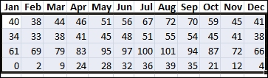

Apply the conditional formatting
- O On the Home tab, in the Styles group, click the arrow next to Conditional Formatting,
- then click Color Scales.
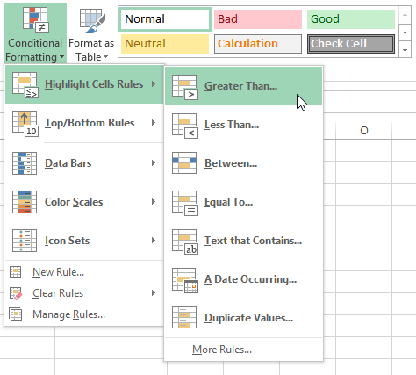
- Hover over the color scale icons to see a preview of the data with conditional fo formatting applied.
In a three-color scale, the top color represents higher values, the middle color represents medium values, and the bottom color represents lower values. This example uses the Red-Yellow-Blue color scale.

After choosing “color scales”, UNDO, then choose “Conditional Formatting” with “Data Bars”

Exercise 6 – Using the PMT function

If you know the result that you want from a formula, but are not sure what input value the formula needs to get that result, use the Goal Seek feature. For example, suppose that you need to borrow some money. You know how much money you want, how long you want to take to pay off the loan, and how much you can afford to pay each month. You can use Goal Seek to determine what interest rate you will need to secure in order to meet your loan goal.
Note Goal Seek works only with one variable input value.

From Handout page: Type cells F26 – I27, in cell h30 include PMT (Financial) function

For PMT function: Go to cell H30

Click Formulas tab, then in “Function Library” choose “Financial” and pick PMT

- Select appropriate cells
- Convert rate to monthly rate by dividing by 12
- Make amount a positive number by placing “-“ sign in front of amount reference
- Monthly payment = $377.42

Exercise 7 – Goal Seek to perform what-if analysis using the PMT function

- Click on cell h30 (the cell where the PMT function is located)
- Select the “Data” tab, then find the “Data Tools” group
- Click “What-if Analysis”, then “Goal Seek”
- Within the “Goal Seek” dialog box, change the To value to 350
- change the By changing cell by clicking on cell F27
- then click “OK”
(later we’ll change H27, & I27)

Note: The cell you choose to Goal Seek (in our example, cell H30) must contain a formula or function

Exercise 8 – Pivot table

An Excel pivot table is a data summarization tool that can automatically sort, count, total or give the average of the data stored in one table or spreadsheet. It displays the results in a second table (called a "pivot table") showing the summarized data.

Sales Person | Sales Units | Product | Total Sales Amount
Emily | 100 | Apples | 50
Dan | 102 | Oranges | 60
Mary | 105 | Apples | 70
Sarah | 250 | Oranges | 90
Emily | 105 | Apples | 60
Dan | 206 | Oranges | 70
Mary | 105 | Apples | 60
Sarah | 250 | Oranges | 70
Emily | 250 | Apples | 90
Dan | 105 | Oranges | 60
Mary | 206 | Apples | 90
Sarah | 105 | Oranges | 60

To create a Pivot Table: Select data
- Click “Insert” tab, then in “Tables” group, click “Pivot Table”
- In “Create Pivot Table” dialog box, click “OK” (pivot table will appear on new worksheet)
- From “Pivot Table Field List”
  - Drag “Sales Amt” to “∑ Values”
  - Drag “Sales Person” to “Row Labels”
  - Drag “Sales Units” to “∑ Values”
  - Drag “Product” to “Row Labels”

Tip – Use Google™, www.youtube.com, and www.gcflearnfree.org for assistance at home

For assistance with any Excel topic:

- In Google™ search box, type (example): Excel 2013 Tutorial “pivot table”
- In www.youtube.com search box, type (example): Excel 2013 Tutorial “pivot table”
- Here is an excellent tutorial website: www.gcflearnfree.org

Thank you for participating in Advanced Excel 2013

