Chromebook Instruction Sheet
Chromebook
A Chromebook is a notebook computer running Chrome OS as its operating system. Chromebooks are designed to be used primarily while connected to the Internet, with most applications and data residing in the cloud. They have been around since 2011. Chromebooks are manufactured by different companies such as ACER, Dell, HP, Lenovo, and Samsung.

Chromebooks are different from a traditional laptop or tablet in the following ways:

- Nothing to set-up or configure
- Log in with a Google account
- Runs on Chrome OS
- Updates automatically
- No software to buy
- Programs are apps
- Built-in virus protection.
- Everything is stored in the cloud, not on Chromebook
- Keyboard has some different keys on it
- Inexpensive
- Faster boot up
- Longer battery life
- Needs WiFi to do work

Google Accounts
A Google account gives access to Google products with a single username and password. To use a Chromebook, you need to log in with your Google account.
Adult | Circ/Admin/Tech | Youth
adult.clpl@gmail.com | iyouth.clpl@gmail.com | icirc.clpl@gmail.com
Paddock126 | Paddock126 | Paddock126

Google Apps
The Chromebook runs on apps, primarily Google apps. These apps open in the Chrome browser.
Some popular Google apps are:
Features of a Chromebook
Keyboard

Touchpad

App launcher & Shelf
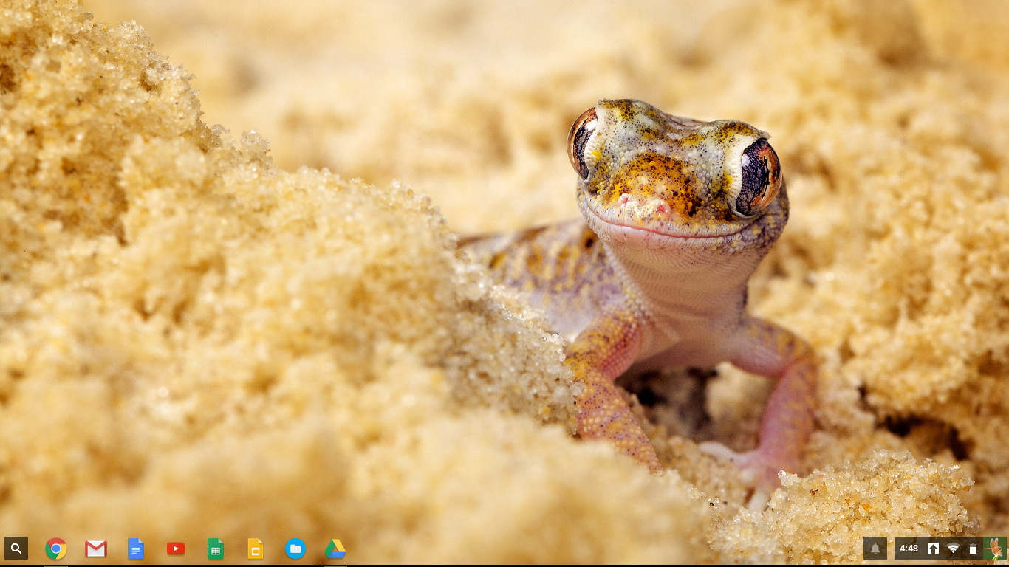

Status area

Printing from Chromebooks at the Crystal Lake Public Library
1.
2.
3.

Additional Resources
Staff can learn more and get additional training from the following resources.
  - Books
    - LaFay, Mark. (2015). Chromebook for dummies. (Axis360 eBook or book from CCS libraries)
    - Miller, Michael. (2015-2016). My Google Chromebook (3rd ed.) (CCS libraries)
  - Lynda.com
    - Up and Running with Chrome OS (39 minutes) Get up and running with Chrome OS, the operating system that runs on Google Chromebooks and Chromeboxes.
    - Google Apps for Students (1 hour 13 minutes) Discover how to use Google Apps to become more productive in class and after school.
    - Google Apps for Educators (2 hours) Shows K–12 teachers how to use Google Apps for Education to streamline communication, save time, and increase content mastery.
    - Google Drive Essential Training (1 hour 31 minutes) Learn about organizing, finding, and sharing files with Google Drive, the extremely popular cloud-based file storage and word processing, spreadsheet, and presentation software.
    - Gmail Essential Training (1 hour 45 minutes) Master the basics of composing, sending, and replying to email in Gmail and then learn powerful configuration and organizational techniques to enhance productivity.
    - Google Calendar Essential Training (1 hour 42 minutes) Learn how to use Google Calendar (free with any Gmail account) to manage your schedule.
    - Google Classroom: First Look (18 minutes) Get a first look at Classroom, the free LMS from Google, and learn how to create a course, add students, and send assignments.
  - Crystal Lake Public Library Computer Classes requires registration
    - Google Drive Basics (September 12 2-3:30 PM)
This hands-on introductory class will cover how to access, use, and organize Google Drive.
    - Google Drive Intermediate (September 26, 2-3:30 PM)
Learn more about Google Drive features, including Sheets, Slides, and Calendar.
  - Websites
    - Google Chromebook Help Center: https://support.google.com/chromebook
    - Tutorials from www.gcflearnfree.org (Chrome, Google Account, Google Drive, Google Maps, Google Sheets, Google Slides, Google Calendar, and Google Forms)
    - Courses from https://techboomers.com (Google Drive, Google Hangouts, Google Maps)
  - Experts
    - Library and Adult Services expert: Ashlee Tominey
    - Circ/Admin/Tech expert: Hallie Sinkovitz
    - Youth Services expert: Terri Smith

