Basic Excel 2013
Microsoft’s Excel 2013 is the electronic spreadsheet program within the Microsoft Office Suite. An electronic spreadsheet is an application you use to perform numeric calculations and to analyze and present numeric data.
Loading (starting) the Excel 2013 Program
There are several ways to start, or load the Excel program. The two most common methods are by using the Start menu (far left-bottom of the screen) or by clicking a desktop shortcut for the Excel program if it is available. If you use the Start menu, the steps will vary slightly depending on the version of Windows you are using. At this time, we will load the Excel 2013 program from the Start menu, and observe the screen layout.
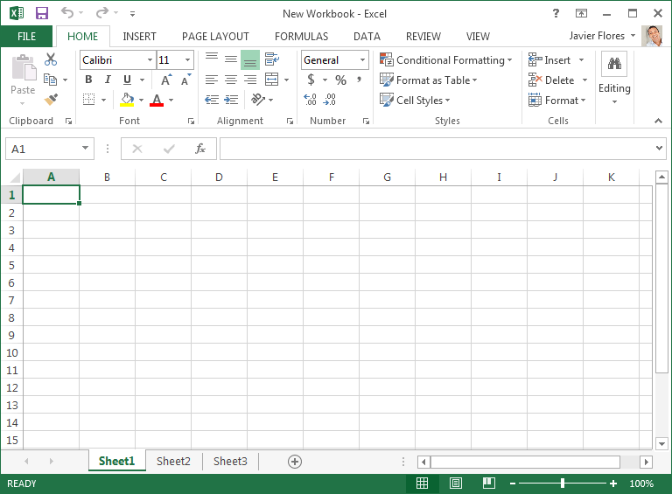
Spreadsheets
A spreadsheet is an electronic document that stores various types of alphabetic and numeric data. There are vertical columns and horizontal rows. A cell is where the column and row intersect. In the illustration above, the active cell is A1. A cell can contain data and can be used in calculations. Multiple spreadsheets are put together to create a workbook. Microsoft Word is known as a word processor; similarly Excel can be considered to be a math processor.

Entering Data – Three types of data are entered onto worksheets:
- Text – always starts with an alphabetic character (a-z)
- Numbers – starts with a number, but can also contain: .$,%.-
- Formulas and functions – starts with “=” sign

Exercise 1 - Creating a Worksheet <depress the “Enter” key or the arrow keys after each line>
Cell Type this data
A1 NPL-Basic Excel Example 1
A3 Type your actual first and last name (example: “Joe Smith”)
C5 Travel Books
D5 Qty
C6 Hawaii
C7 California
C8 Florida
D6 10
D7 2
D8 4
D9 =SUM(d6:d8) We will go to the “Editing” group and select “AutoSum”
Home tab introduction: Font, Alignment and Number groups
- Font Group – Font shape and size; bold, italics and underline; fill and font color
- Alignment group – left, center and right justification; top, middle, and bottom align
- Number group – Number, currency, percentage, date, text,”$”, and more
- Performing Calculations: = (starts formula), + (add), - (subtract) * (multiply) / (divide) ^ (raise to the power) [example 4^2]
Exercise 2 - Modifying a Worksheet – depress “Enter” key or arrow keys after each line
Cell Type this data
E4 Average
E5 Cost
E6 18
E7 22
E8 20
F5 Total
F6 =d6*e6
F7-F8 we will select cell F6, and fill down through cell F8
F9 =Sum(f6:f8)

Exercise 3 - Modifying a Worksheet – Inserting a row
Insert a row after row 7 (between California and Florida):
Cell C8: Illinois Cell D8: 5 Cell E8: 15 Cell F8: fill down from cell F7
Very Important – Double check your formulas! Here’s how to do a quick check:
Exercise 4 – To verify and show formulas within the worksheet
1. Click “Formulas” tab
2. In the “Formula Auditing” group, click “Show Formulas”

Quick Access Toolbar
The quick access toolbar is a customizable toolbar that contains commands that you may want to use. You can place the quick access toolbar above or below the ribbon. To change the location of the quick access toolbar, click on the arrow at the end of the toolbar and click “Show Below the Ribbon”.

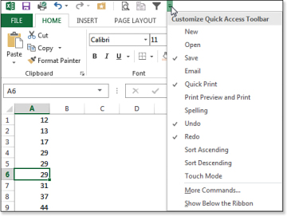
You can also add items to the quick access toolbar. Right click on any item in the Office Button or the Ribbon and click Add to Quick Access Toolbar and a shortcut will be added.

Ribbon
The ribbon is the panel at the top portion of the document and has seven tabs: File, Home, Insert, Page Layout, Formulas, Data, Review, and View. Each tab is divided into groups. The groups are logical collections of features designed to perform function that you will utilize in developing or editing your Excel spreadsheets.
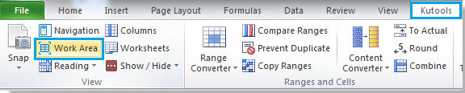
Commonly utilized features are displayed on the Ribbon. To view additional features within each group, click the arrow at the bottom right corner of each group. This will display a “dialog box” on your screen.

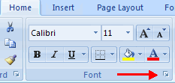
Tabs Groups contained within the Tab
File: Opening existing worksheets, and saving and printing worksheets
Home: Clipboard, Fonts, Alignment, Number, Styles, Cells, Editing
Insert: Tables, Illustrations, Charts, Links, Text
Page Layouts: Themes, Page Setup, Scale to Fit, Sheet Options, Arrange
Formulas: Function Library, Defined Names, Formula Auditing, Calculation
Data: Get External Data, Connections, Sort & Filter, Data Tools, Outline
Review: Proofing, Comments, Changes
View: Workbook Views, Show/Hide, Zoom, Window, Macros

Delete Cells, Rows and Columns - To delete cells, rows, and columns:
- Place the cursor in the cell, row, or column that you want to delete
- Click the Delete button on the Cells group of the Home tab
- Click the appropriate choice: Cell, Row, or Column
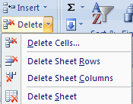

Backstage view – Where you go to open, save and print worksheets
Exercise 5 - Save a Workbook - When you save a workbook, you have two choices: Save or Save As.
To save a document:
- Click the File tab (this takes you to “Backstage” view
- Click Save As (directs the file to a folder and names the file)

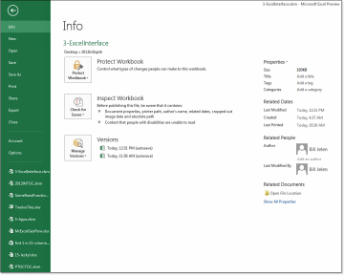
You may need to use the Save As feature when you need to save a workbook under a different name or to save it for earlier versions of Excel. Remember that older versions of Excel will not be able to open an Excel 2013 worksheet unless you save it as an Excel 97-2003 Format. To use the “Save as” feature:
Exercise 6 - Open a Workbook - To open an existing workbook:
- Click the File tab and follow the prompts (you are in Backstage view)

Exercise 7 - Page printing
- Click the “File” tab which leads you to “Backstage” view
- Along the left side of screen, click on “Print”

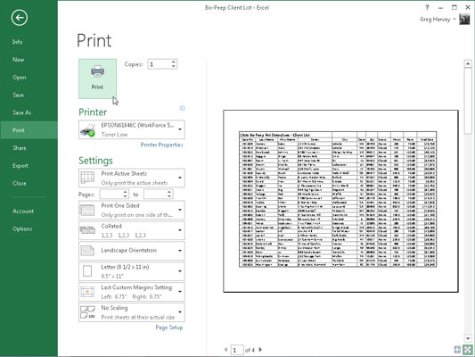

Tip – Use Google™, www.youtube.com, and www.gcflearnfree.org for assistance at home
For assistance with any Excel topic:

- In Google™ search box, type (example): Excel 2013 Tutorial “formulas”
- In www.youtube.com search box, type (example): Excel 2013 Tutorial “formulas”
- Here is an excellent tutorial website: www.gcflearnfree.org

Practice / Practice / Practice - The best way to retain what you learned today is by practice using Excel daily for the next several days
Thank you for participating in Basic Excel 2013
Consider enrolling in the next session

INTERMEDIATE EXCEL 2013
Covers inserting charts into spreadsheets, changing chart types, moving charts, validating formulas and functions, reviewing Excel templates and much more.

