Open Pivot Table Data-1.xlsx which contains the data we will analyze. This table represents a relatively small amount of data but you can see it would be difficult to answer such questions as:
- Which student had the highest average score in French?
- In what month was overall grades the highest? Lowest?
- Is there a student who needs help in a given subject?
Pivot tables allow you to organize and analyze data to more readily reveal useful information.
In a previous lesson we talked about creating a table or database in Excel. The data you use for a Pivot Table must also qualify as a database table. Before you can create your Pivot Table, be sure your source data meets the following criteria:
1. The top row of data must contain column headers.
2. Each row of data is a record about one particular entity or transaction.
3. Each column of data holds the same kind of information.
4. There are no entirely blank rows in the data.
5. There are no entirely blank columns in the data.
6. If a column contains numbers, use a zero instead of a blank cell when you don’t have a value.
To begin you need to select the data to be analyzed. To select the data to be used in the Pivot Table analysis you can either:
- Select any cell within the data table, or
- Highlight the data that you want to include in your Pivot Table, in this case, cells A1 to D37.
then
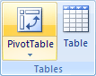
- On the ribbon, click the Insert tab and in the Tables group click on the Pivot Table icon.

- If you forget the source data criteria noted above and you don’t have a label heading on every column you will see the following message:
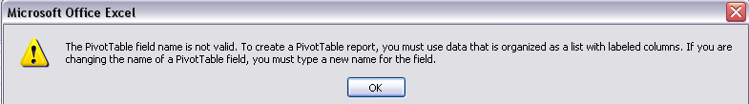
Click OK and return to the data table and be sure every column has a heading at the top - the “Student” column header is missing at the top of Column C - add the header then restart the process from #1 above.
However, if everything is as expected the Create Pivot Table dialog will open.
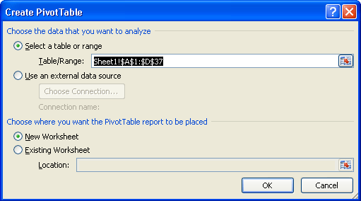
The first section of the dialog identifies the table or range to be used in the pivot table. The range you selected is already noted. The second section will determine the final location of the Pivot table - in a new Worksheet or in the existing worksheet at a location you select. For our purposes select the New Worksheet option if it’s not already selected. Click OK.
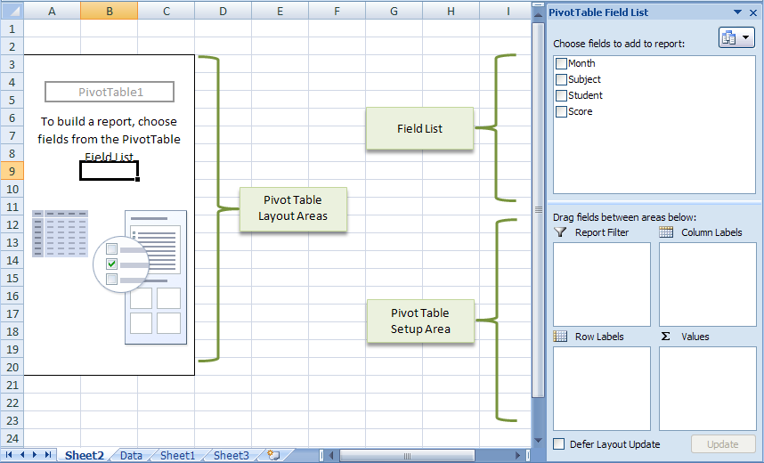
- When you click OK, Excel moves you to a new worksheet on which the Pivot Table will be “built”. On the left‐hand side of the screen is the pivot table layout area. The fields you choose will appear in this area. On the right‐hand side of the screen, you will find the Pivot Table Field List which is made up of two main areas. At the top is the actual listing of all of the available fields in the source data worksheet. Below that area is the Setup Area with four blocks representing individual components that will be use to “construct” your pivot table (row labels, column labels, values and report filter).
- Next, notice that the Ribbon now has the Pivot Table Tools with its Design and Layout tabs.
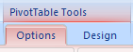
Note: If you “lose” the field list and/or Pivot Table Tools all you need to do is click your mouse anywhere inside the pivot table and they will reappear.
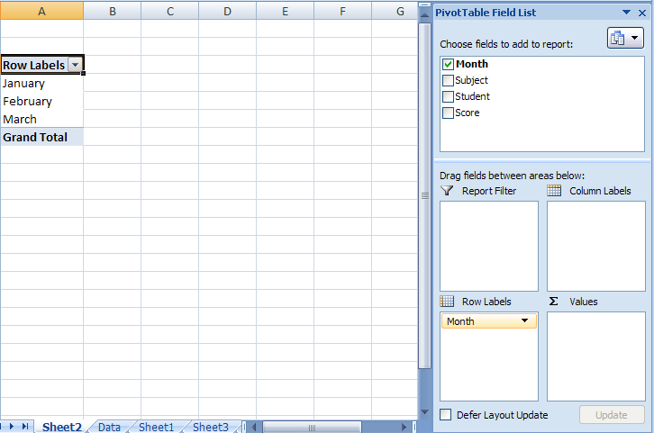
- Select the Month field in the Pivot Table Field List and you will begin to see the pivot table “grow”. Your screen should look like this:

Note how each area has changed based on this selection. The Month field appears in the row labels area and the months from the source data appear in the pivot table in the left column.

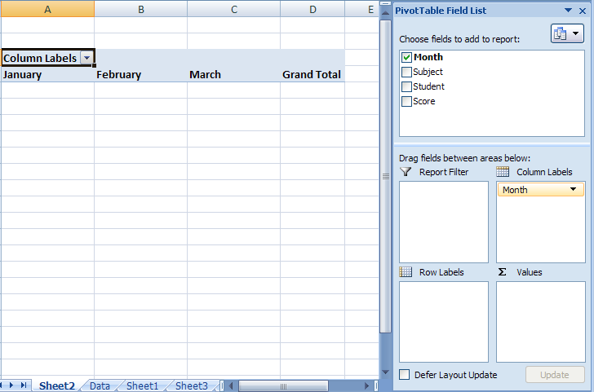
Let’s say you want the months to be the Pivot Table Column headers. In the Pivot Table Field List Click and hold on the yellow Month field in the Row Labels section and drag and drop that field to the Column Labels section and see how it changes the sample. Now your Pivot Table will look like this:

- Continue to add fields to your pivot table until your screen looks like this:
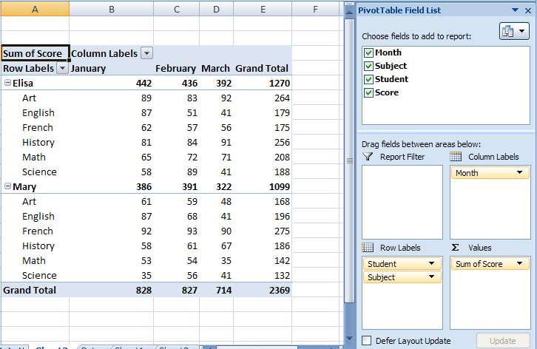
- Next, in the Pivot Table Field List, move (drag and drop) the Subject field so it’s before the Student field in the Row Labels box. Now your data changes to look like this:
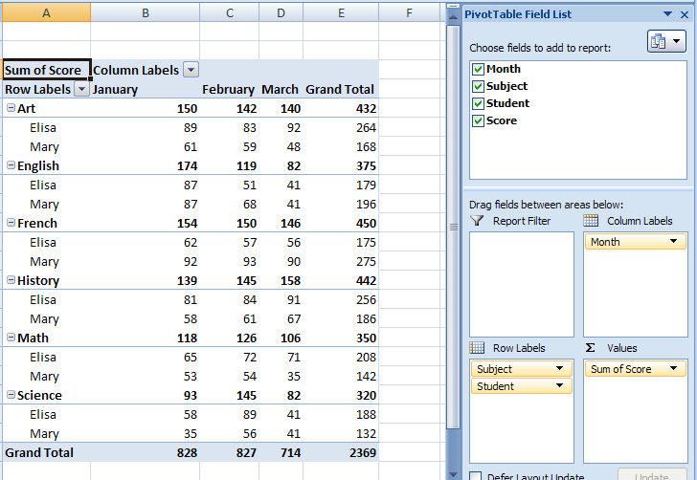
- Next Drag the Month field and place it after the Student field in the Row Labels box. Next drag and drop the Subject field in the Column Labels box. Your finalized layout of your Pivot Table will look like this:
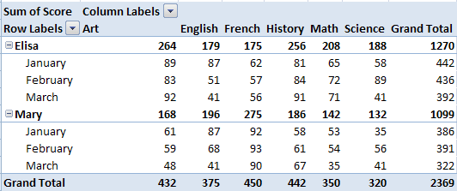

Formatting the Pivot Table
Fields that are placed in the Values section always have a math function associated with them. In this case the name shown in the Pivot Table is Sum of Score. A better name might be nice. Also, since these are grades, it might be more useful to see the scores as averages rather than totals. Formatting the numbers may also be necessary as we will see. These formatting changes are easily accomplished using the Value Field Settings dialog. There are a couple of ways to get to these settings:

- Click on any score number in the pivot table and notice on the Pivot Table Tools appears. On the Options Tab, the Active Field group identifies the chosen field as Sum of Score. The field name is displayed in a text box and it can be edited there. Note that you are not permitted to change the Pivot Table field name to “Score” because that is the actual field header name in the data. You must change the name, if only slightly. Change the active field name to show the name Score by adding a space before or after the word and it will be changed in the text box and in the Pivot Table.

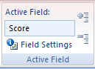
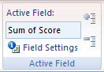
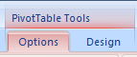

If that were the only formatting change you wanted to accomplish you would be done. However we also want to average the scores rather than total them. In the Active Field group shown above there is an option for Field Settings. Clicking on that option will brung up the Value Field Settings dialogue:

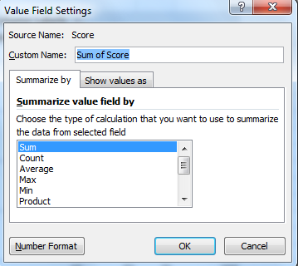

Optionally you can open these settings by clicking on the dropdown arrow at the end of the Sum of Score field in the Pivot Table Field List.

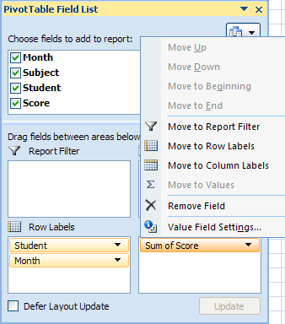

- Use either option to select the Value Field Settings and the Value Field Settings dialog will appear. Notice you can rename the field in the Custom Name text box in this dialog. In addition, in the Summarize value field by section you will notice that “Sum” is already selected but there are other options in the list. For our purposes we’ll choose Average.

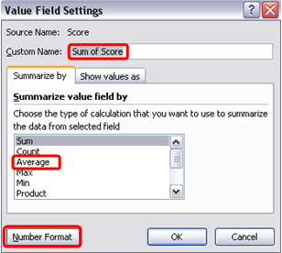

The last option we want to take care of is the numbers format. If you select Average and then click OK, here’s what your Pivot Table would look like – not very “pleasant”. Therefore let’s change the number format.

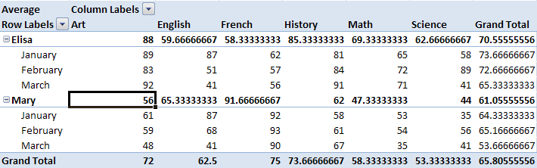

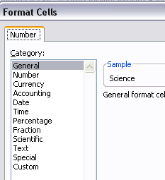
- Click the Number Format button at the lower left side of the dialog and the familiar Format Cells dialog will appear.

- In the Format Cells dialog select the Number option in the category list then select zero (0) decimal places on the right side of the dialog and click OK.

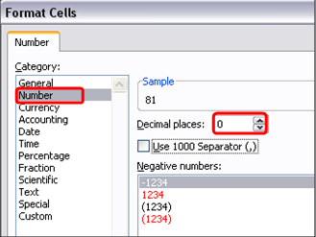

- Your almost-complete Pivot Table now looks like this:

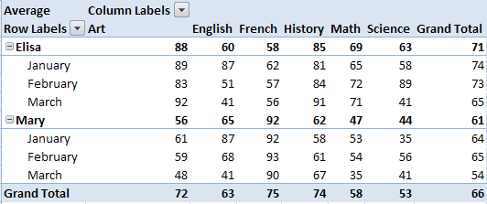

- We changed the numbers to be average scores but the table stills says “Grand Total”. Also the words “Column Labels” above the Art column makes that column look much wider than the other columns. We can changes these titles and make our final output more aesthetically pleasing. Just click in the cell with the words “Grand Total” and the formula bar will show that the text can be edited. Type the word “Average” and press Enter. Now Click in the cell with the words “Column Labels” and remove the word Labels. Now do the same to the cell with the words “Row Labels”.

- Now your Pivot Table looks like this:
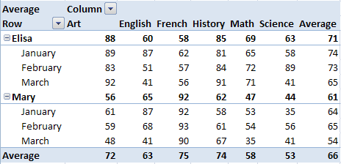
- Notice that there are dropdown arrows next to the words Column and Row. Using these dropdowns allows you to filter the data shown in the pivot table. You can tailor your view of the data by clicking on those arrows and selecting one or more of the options to filter data in or out of the pivot table view. For example click on the dropdown next to Row and uncheck Elisa’s name. Now your table shows only data for Mary. Go back and check the Select All option. Now click on the arrow next to Column and uncheck Select all and then select French and English from the list. How does the Pivot table look now?

- Many design options are available to you on the Pivot Table tools, Design Tab in the Pivot Table Styles group. Use the dropdown arrow at the side of the group for lots of options for colors and styles. Find your favorite and see how it looks compared to this one:

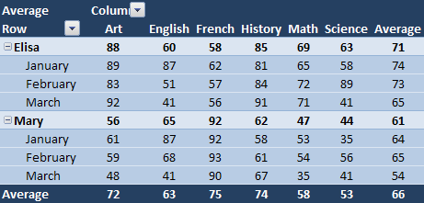

Pivot Table Practice Exercise
You’ve recently been hired by XYZ Consulting Company. The position you’ve accepted has been vacant for over 6 months. Part of your new duties will be to handle client rebate payments. The company bills, collects and pays its client rebates for food purchases. The manufacturers are billed either monthly or quarterly and it will be your job to invoice and collect the rebates and pay the clients on a timely basis. Some of the clients have complained that many of their rebates are long past due. Your manager has asked that you begin by concentrating on collection of the oldest items dating back to 2011.
The Accounting Department has provided you with a list of the unpaid rebate invoices in an Excel Workbook,
Pivot Table Data-2-Rev.xlsx.
Using the data in this Excel file:
- Create a Pivot Table that will show the payments due from each Manufacturer for each client by Invoice Number. Your beginning pivot table will look like this:
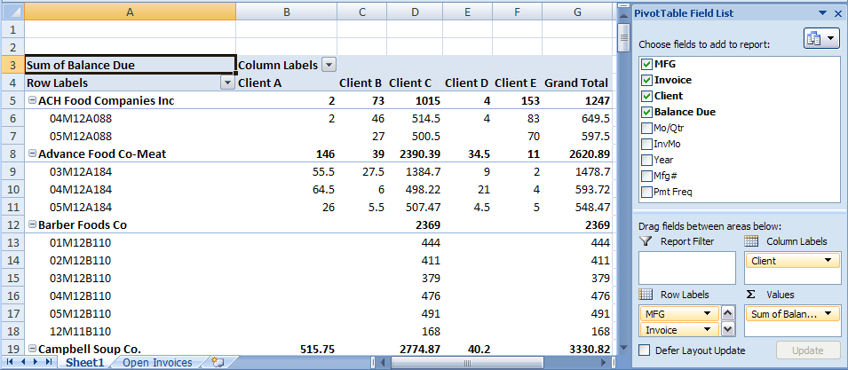
- Format the invoice amounts (Balance Due) as currency with two decimal places.

- Filter the data so that you can see only the oldest items issued in 2011. To add a filter choose the Year field and drop it in the Report Filter section in the lower part of the Pivot Table Field List area. You will now see an addition to Cells A1 and B1. By default, (All) is shown in cell B1 indicating all data is shown – no filter has yet been applied.

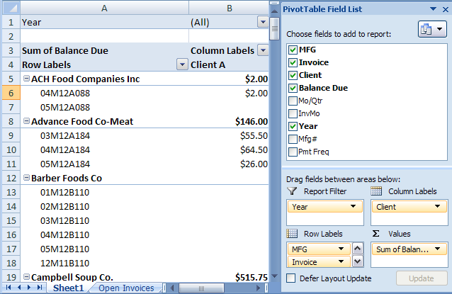

- Click on the dropdown arrow to the right of (All) and you will see this dropdown:
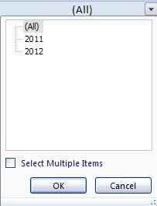

Click to Select Multiple Items and you will now be able to select or deselect any of the years available in this database. Uncheck the boxes next to All and then select 2011 and click OK.
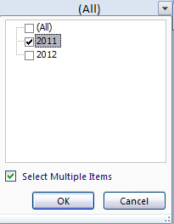
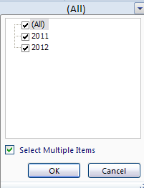

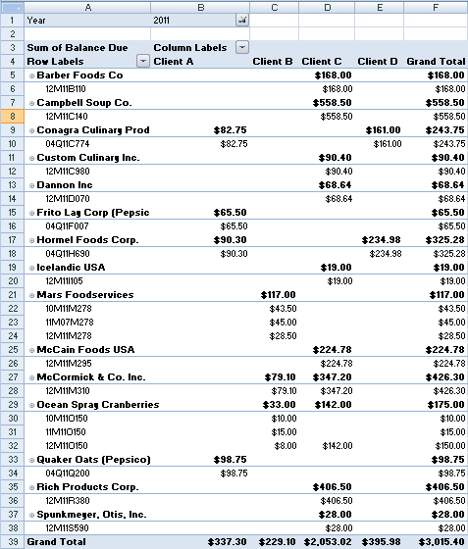
You will use this information to contact the Manufacturers to collect the delinquent payments for your good mutual clients.

The Pivot Table Tools, Design tab, Pivot Table Styles group has many preset options that will allow you to quickly and easily enhance the look of your pivot table. Try several options until you find one you like. Your Completed Pivot Table may look something like this:
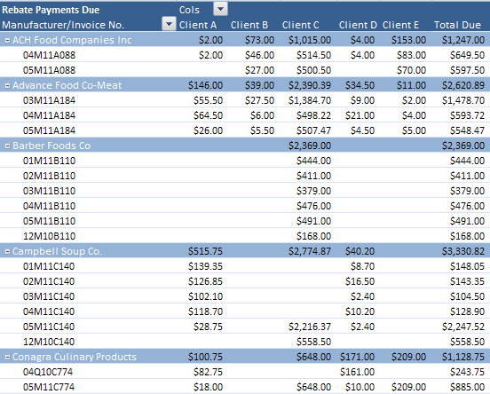
Note: This is only the first few manufacturers listed in the Pivot Table.

