Step 1: Open the Internet Explorer and select the Google Site.

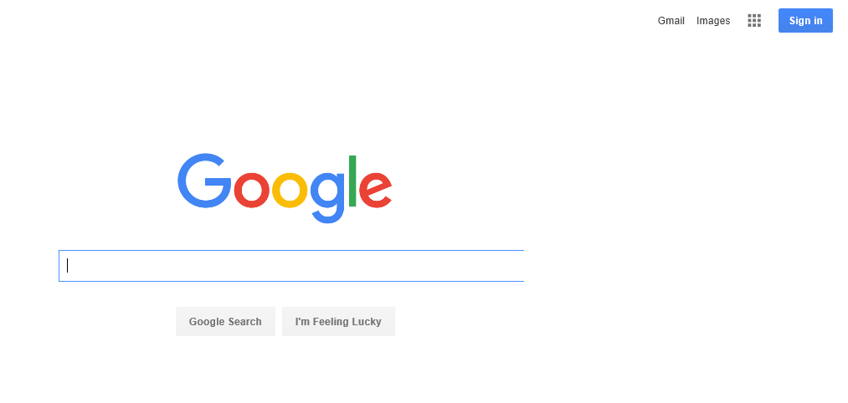
Click to Sign In

Step 2: Sign in with your Google Account
If you have a Google Account, enter the e-mail and password previously established and skip to Step 5.

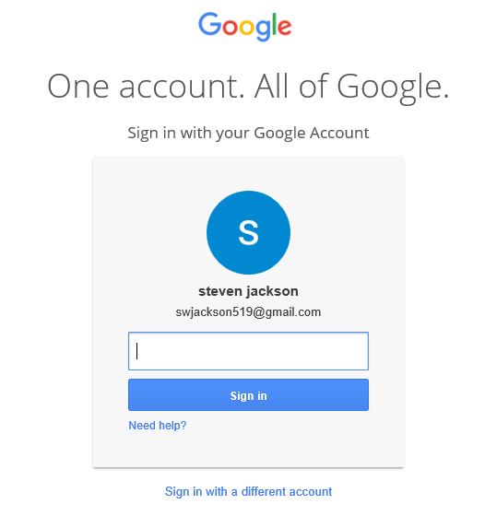
Enter password

Step 3: Use the e-Mail link
If you do not have a Google Account, click the “Open” button in the e-mail giving you access to the shared “PowerPoint” folder on the Google Drive.
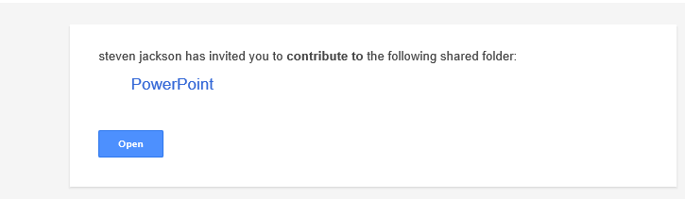
Click to open shared site

Step 4: View the Shared Folder
The Google Drive “PowerPoint” folder will appear with the classes shared documents.
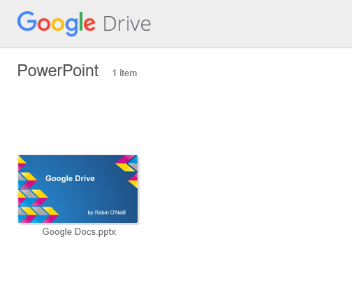

Note: You cannot save your files in the Shared Site, you must have a Google account!
Step 5: View your Google Drive
- If you have a Google Account, you will see the Google Drive page with the index shown below.
- Select “My Drive” to see your documents.
- Select “Shared with Me” to see documents shared on other Google Drives such as “PowerPoint”

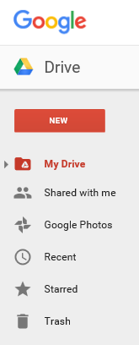
Click to see your files
Click to see shared files

Step 6: Download your documents
- Point to the document and click the right mouse button and select the “download” option. The file will appear in the “Downloads” folder on your machine.
- Copy the file from the Download folder into your working folder.
Step 7: Upload your Documents
- Point to a blank location on the display and click the right mouse button.
- Choose the “Upload Files..” option.
- A file explorer dialog panel will open. Locate and check the file(s) to upload.
- After all of the files to upload are chosen, click the “Open” button.

